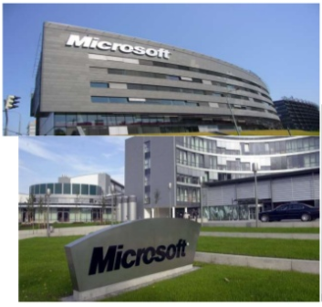  Mission statement.  To empower every person and every organization on the planet to achieve more.  Vision Statement.  To help people and businesses throughout the world realize their full potential.
  Who We Are
  Microsoft is an American multinational technology company headquartered in Redmond, Washington.
  About Us
  The company creates, manufactures, licenses, supports as well as sells computer software, personal computers, consumer electronics, and related services.
  Contact Us
  Phone: (020) 286-8000
  Email: microsoft@gmail.com
  Web:
  www.microsoft.com
  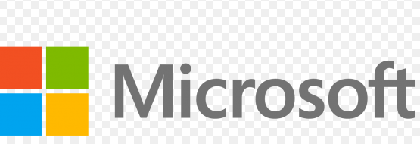 | MICROOFT CORPORATION  5000 148th Ave NE, Redmond, WA 98052, USA
  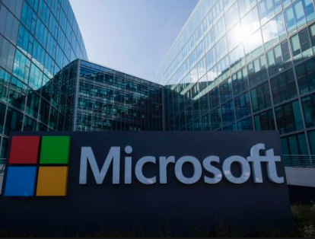
  MICROOFT CORPORATION
    - Products offered at Microsoft Corporation.
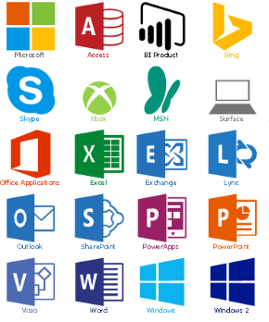  Microsoft Products | Our Products.  Our company offers;  - Windows server.  - Office 365.  - Microsoft Office Suite.  - Windows Client.  - SQL Server.  - SharePoint Server.  - Microsoft Azure.  - Dynamic ERP.  - Exchange Server.  - Skype for Business.  Microsoft products are simply the best. | 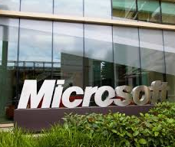  Benefits of using our products.  - The ability to establish great charts.  - There is fluency of MS Office.  - Ability to collate data together.  - Flexibility of work.  - Better career prospects.  - Acute integration of technology into work.

